Authentication Documentation
2. Authentication Logic (BLL)
- Custom Auth Service: Handle Login/Register logic in the BLL.
- Session/Cookie Management: Use Cookie Authentication Middleware manually to manage user claims (Name, Email, Role).
- Password Handling: Use BCrypt.Net or IdentityHelper for hashing and verifying passwords.
3. Registration Flow
- Manual Registration:
  - A single Register page where the user fills: FullName, Email, Password, Phone, and selects Role.
  - If Role is "Worker", show an extra input for Specialty.
- Post-Registration: Data must be saved in both the base Users table and the specific sub-type table (Workers or Customers).
4. Google OAuth Integration
- Login Flow:
  - User clicks "Sign in with Google".
  - Case A (Existing User): If the GoogleId or Email exists in the DB, log them in and redirect based on their role.
  - Case B (New User):
    - Fetch Email and Name from Google.
    - Redirect to a "Complete Profile" page to choose Role and enter PhoneNumber (and Specialty if they choose Worker).
    - Create the user record in the DB only after this step is completed.
5. Login & Redirection Rules
- Manual Login using Email and Password.
- Role-Based Redirects:
  - Admin -> AdminPanel/Dashboard
  - Worker -> Worker/Profile
  - Customer -> Home/Index
- Implement [Authorize] attributes or custom Middleware to protect these routes based on the Role claim.
Function Name | Parameters (Inputs) | Return Type (Output) | Dependencies | Description (Arabic)
Register | fullName, email, password, phone, role, specialty | (bool Success, string Message) | UserRepository, AppDbContext, BCrypt | تشفير كلمة المرور، إضافة المستخدم، وإنشاء سجل (فني/عميل) ومحفظة للفني.
Login | email, password | User? (Object) | UserRepository, BCrypt | البحث عن المستخدم بالإيميل ومطابقة كلمة المرور المشفرة (Hash matching).
FindByGoogleId | googleId | User? (Object) | UserRepository | البحث في جدول المستخدمين عن مستخدم يحمل معرف جوجل المحدد.
FindByEmail | email | User? (Object) | UserRepository | البحث في جدول المستخدمين عن بريد إلكتروني محدد.
LinkGoogleId | User user, googleId | void | AppDbContext | تحديث سجل مستخدم حالي لربطه بحساب جوجل.
RegisterGoogleUser | fullName, email, googleId, phone, role, specialty | (bool Success, string Message) | UserRepository, AppDbContext | إنشاء حساب جديد تماماً للمستخدم المسجل عبر جوجل وحفظ بيانات الدور والتخصص.
Technical Documentation
1- AuthService Methods
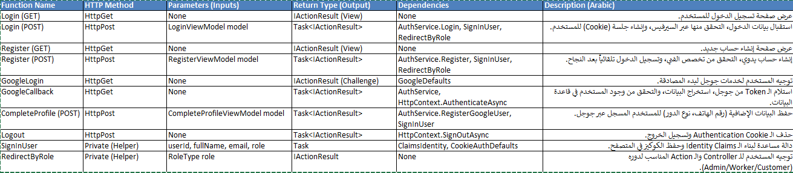
2- AccountController Actions

Flow Chart

